Second International Conference on
Heritage, Innovation and Transformation
7-9 February 2025
Mahendranagar, Nepal
Organised by:
Far Western University, Nepal (सुदूरपश्चिम विश्वविद्यालय, नेपाल)
Co-organised by:
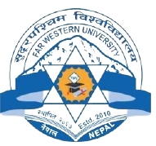
Indian Institute of Technology Roorkee (IITR), India

Abstract Submission Format
Title of the paper
Author(s)

Author’s affiliation

Contact details of presenting author(s) | Tel:  Email:
Abstract text (maximum 300 words)
Please indicate your preferred presentation format: | - Oral presentation with PowerPoint [ ]  - Oral presentation without PowerPoint [ ]  - Poster presentation [ ]  - Film presentation [ ]  - No preference [ ]

